AIM: To implement Linear Regression in Python to predict students' marks based on the number of hours studied and evaluate the model's performance using Mean Squared Error (MSE) and R² Score.

ALGORITHM:
- Start the program.
- Import the required libraries: Pandas, Matplotlib, and Scikit-learn.
- Load the student dataset from the data.csv file.
- Remove extra spaces from the column names.
- Select Hours studied as the input feature and Marks as the target variable.
- Split the dataset into training and testing sets in an 80:20 ratio.
- Create a Linear Regression model.
- Train the model using the training data.
- Predict students' marks using the testing data.
- Calculate the Mean Squared Error (MSE) and R² Score to evaluate the model.
- Display the predicted marks and evaluation metrics.
- Plot the actual marks and regression line using Matplotlib.
- Display the graph.
- Stop the program.

OUTPUT:
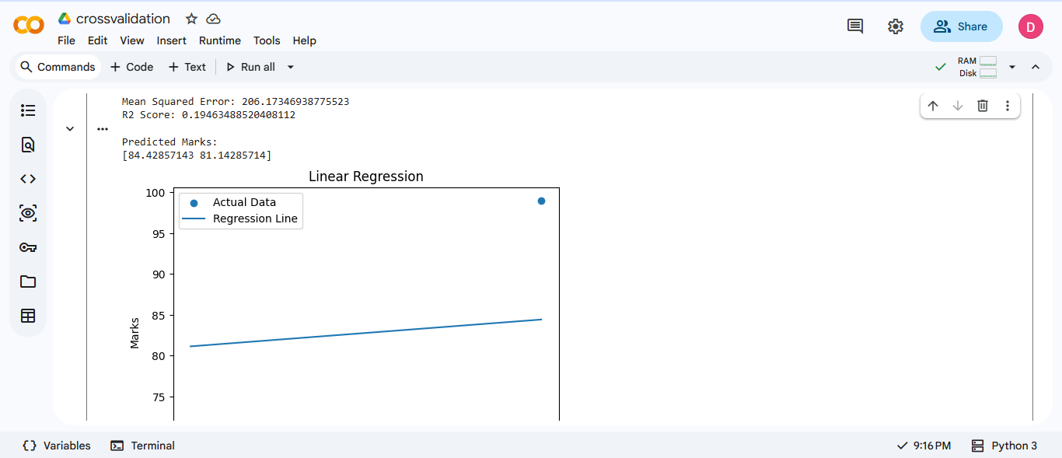

RESULT: Thus, the Linear Regression model was successfully implemented in Python to predict students' marks based on the hours studied. The model's performance was evaluated using Mean Squared Error (MSE) and R² Score, and the predicted marks and regression graph were displayed successfully.

